|  |
| --- |
|  |
| TD Talks |
|  |
| By: Kevin Postma and Steve Mahabir |

**INFO-3097: Mobile Development**

November 18, 2015

Authored by: Steve Mahabir

TD Talks

By: Kevin Postma and Steve Mahabir

# Description

Short Message Service (SMS) messaging, popularly known as text messaging, is a powerful mobile communication tool that allows financial services institutions to interact with their customers in a cost-effective and timely manner.

TD Talks is a Group Text Messaging mobile application that will allow you to send text messages between multiple clients. You can send single messages, or multiple messages depending on what you as the user, or the company

# Program Tutorial

Upon starting the application, it will automatically search the phone for all contacts (see figure 1). After loading all contacts, the user can choose to send a message to a contact, or add a new contact to message.

To edit a contact, one would just click and hold a contact to open the contact management page (see figure 2). Once the contact management page is open, a user can add the Name and Company Name the person works for.

You can then send a text message to single user or an entire company by selecting “Message Company”.

The application will also act as a message receiver. When anyone response to any of your SMS Text Messages, you will receive a push notification that will show you what the message was.

At the bottom on the application is a link to the TD Website.

## Screenshots

Figure 1 Figure 2 Figure 3

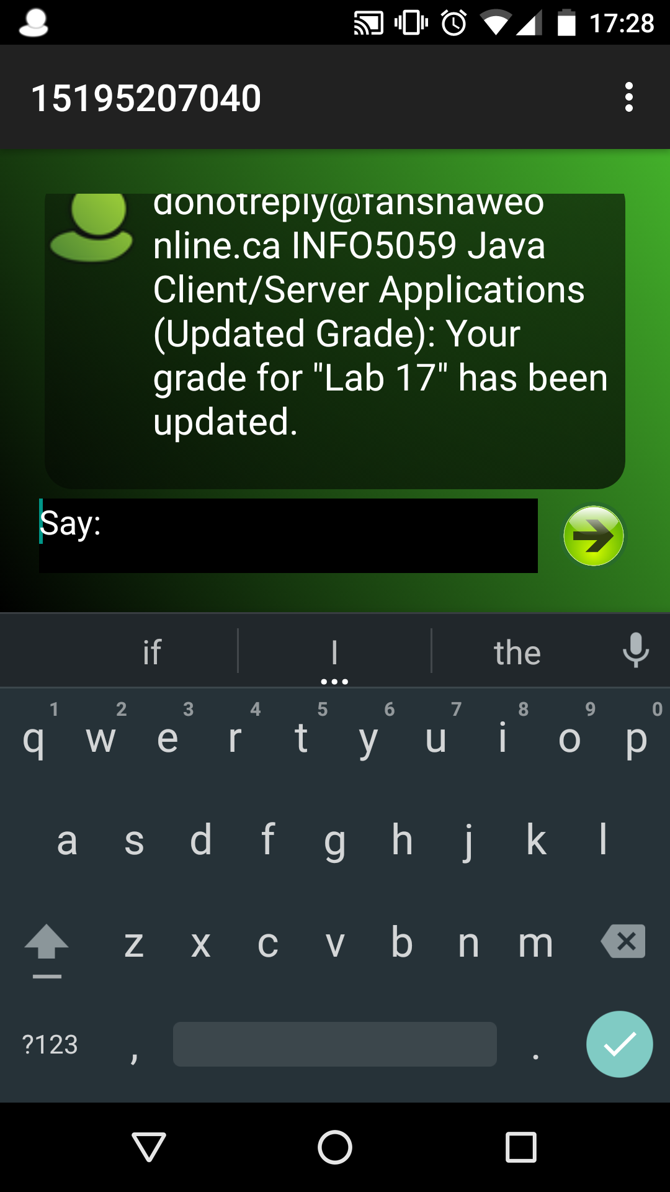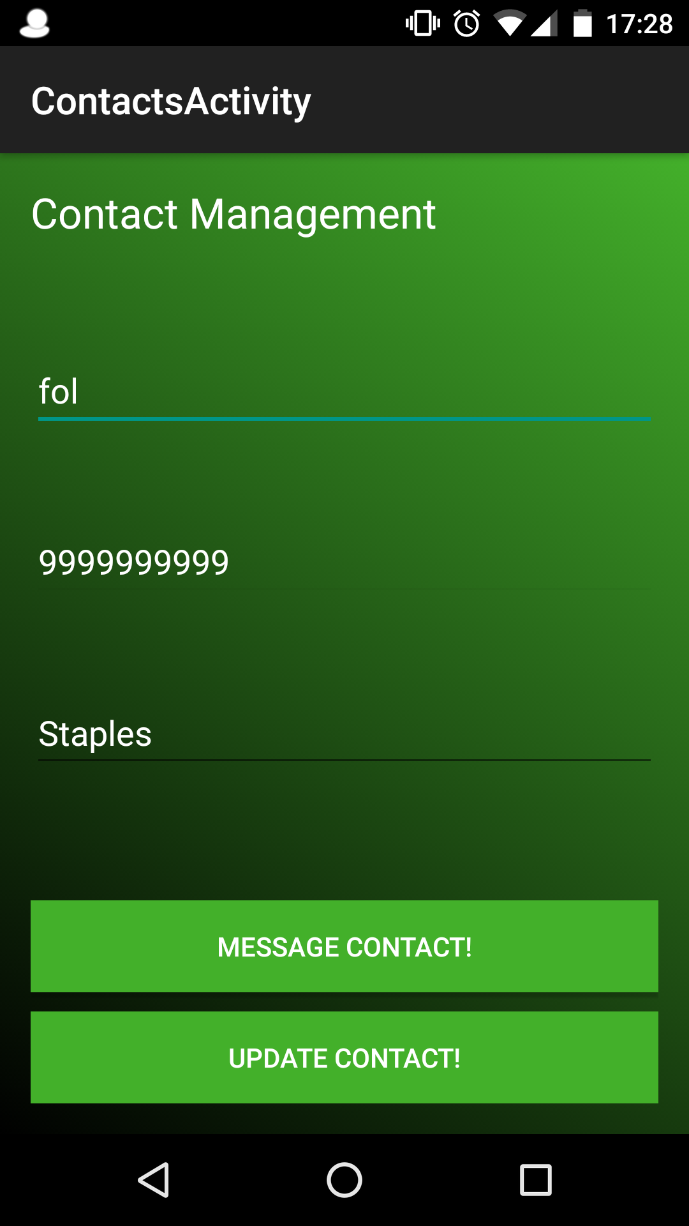

]

\

All Contacts Contact Management Chat Window

# Final Thoughts

The electronic nature of SMS makes it much faster than traditional written communication methods like mail or e-mail because the message is sent directly to the recipient's mobile device rather than a physical or virtual mailbox. This allows financial services institutions near-immediate access to their clients, making SMS an ideal medium for quickly distributing time-sensitive information to an individual or to a broad audience. This quality, as well as SMS's message length limitation (which also lowers bandwidth requirements and delivery expense), makes it more cost effective than other communication channels.

SMS is the way of the future and should be utilized in some way in every mobile communication app.